**Safe Sport Day: 8th August 2025**

**Social Media Guide**

Join the campaign on Safe Sport Day and help us raise awareness of the importance of safe sport for every child.

In 2025, our theme is: **The people who make sport safe.**

**Join us in celebrating the unsung heroes of sport – your safeguarding leads – and everything they do to champion safe sport for every child!**

**Key Messaging:** **It’s people who make sport safe!**

**Call to Action: “**We've committed to keeping children safe in sport every day. Make that commitment too and join #TeamSafeSport!”

**What you can do before Safe Sport Day:**

1. Create a social media **countdown** leading up to Safe Sport Day.
2. **Introduce your safeguarding lead** and tease what they will be posting about on Safe Sport Day.
3. **Learn more** about the International Safeguards at [SafeInSport.org](http://www.safeinsport.org).

**What you can do on Safe Sport Day:**

1. **Celebrate your safeguarding lead** and the work they do every day to make sport safe for children. You could ask your safeguarding lead to document a day in their life in the run up to Safe Sport Day or hand over your social media channels to them on August 8th itself! See the annex for ideas.
2. Use August 8th to **announce your latest safeguarding success or initiative**.
3. If you haven’t done it, **take the Safe Sport Pledge** [**here**](https://safeinsport.org/take-the-pledge/) **and** **then share**.
4. Invite your athletes to **post on their own accounts** about safeguarding and Safe Sport Day. Suggested prompt: **Celebrate who makes you feel safe in sport and why it is important.**

**Graphics:** We have created [this graphic](https://culture.safeinsport.org/resource-uploads/Make%20Sport%20Safe%20SSD25%20nstagram%20ENG1.png) for you to adapt and use.

**Best Practice Guidance (Facebook, Twitter, Instagram, LinkedIn)**

**Always include these hashtags:**

**#SafeSportDay + #TeamSafeSport**

**Tag:**

Facebook and X: **@SafeInSports**

Instagram: **@internationalsafeguards**

LinkedIn:**@international safeguards for children in sport**

**Like, Share, Retweet, Repost:**

**Facebook:** Follow page, and like and share posts: <https://www.facebook.com/SafeinSports>

**X:** Follow, like, and retweet: <https://x.com/SafeinSports>

**Instagram:** Follow, like, and repost: <https://www.instagram.com/internationalsafeguards/>

**LinkedIn:** Follow, like, and repost:<https://www.linkedin.com/company/international-safeguards-for-children-in-sport/>

**Photos and Videos**

Video is key, especially video of your athletes and safeguarding champions sharing their thoughts about safeguarding!

**When photographing or filming:**

* **Lighting.** Natural light is best! Film outside or set up near a window. If that is not an option, try to get it as bright as possible.
* **Get creative and have fun!** Film or take a photo on your field of play.
* **Get close.** Instead of “zooming in”, move in as close to your subject as you can.
* **Get permission** before sharing any photo or video, especially for children 17 and under (see additional guidance below).

**Guidance Around Images and Films of Children**

If you involve children in the campaign, it is really important you get their **informed consent** before using photos or videos of them. *Informed consent* means giving permission in **full knowledge** of the possible consequences.

Click[here](https://culture.safeinsport.org/resource-uploads/Guidance%20on%20images%20of%20children%20for%20SSD.docx) for more guidance and a sample release form.

**Annex:** **A Day in the Life of a Safeguarding Lead**

Please use the following content as inspiration. This represents a very busy day in the life of a Safeguarding Lead during a big international event – but don’t worry if you pick a day that has less going on – it will still be interesting for people to find out what Safeguarding Leads do!

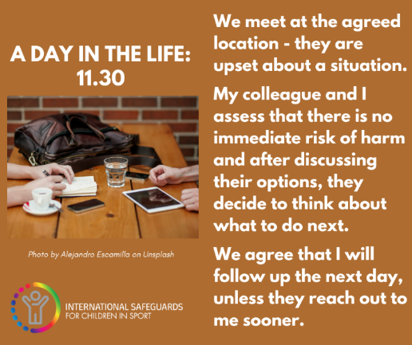

You could ask your Safeguarding Lead to document a day in their life in the run up to Safe Sport Day or hand over your social media channels to them on August 8th itself!